HISTORY OF LAS VEGAS HIGH SCHOOL

Most people believe that the first school in Las Vegas was held in a tent in 1905. In reality, the first school was held in the old Las Vegas Mormon Fort in 1855. There were never more than three upper-grade students since they were involved in the day-to-day farming activities. The first teacher was Elijah Fuller. He earned $3 a quarter. The school was abandoned in February, 1857 when the missionaries were called back to Salt Lake City.

Because funds originally set aside for a school were used to build a jail, a tent was set-up under the cottonwoods near the Las Vegas Creek north of town for 17 primary and secondary students, and used for the 1904-1905 school year.

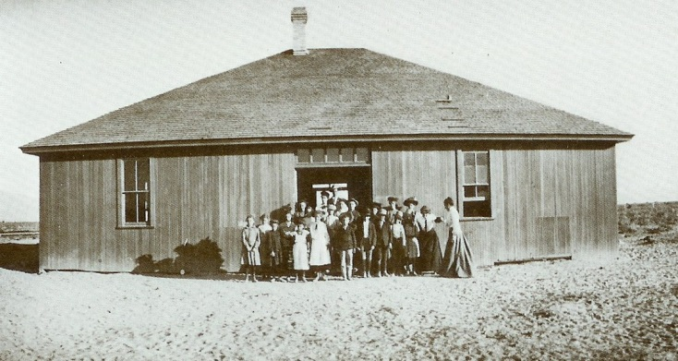
During the summer of 1905, the tent was converted to a courthouse, so the old Salt Lake Hotel was purchased for $150, moved to the southwest corner of 2nd and Lewis, and remodeled at a cost of $550. School opened October 2, 1905 with 64 students and 2 teachers. There were 114 students by the end of November. The 40’ x 50’ wooden building had two rooms, was heated with a pot-bellied stove, had a patch board ceiling and walls covered with cloth and paper. The school year ended early, on March 30, 1906 due to “lack of funds”.

In 1909, due to overcrowding, the nine high school students attended school at the Methodist Church at 3rd & Bridger. Parents were charged $5 per student.

After Clark County was created (when it was split off from Lincoln County on July 1, 1909) funding was not available, so in April, 1910, a $30,000 bond was approved for a combined grammar and high school. The new school would be built on land bordered by Bridger, 4th and 5th Streets, just north of Lewis.

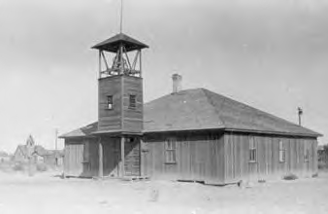
In anticipation of the new school building, the wooden building was sold to E. W. Griffin in an auction in June, 1910. However, before the new school was completed, and shortly after the addition of a bell and belfry (for which the students raised money), the wooden school building burned down on October 29, 1910. Many people believed the fire was intentionally set.

All classes were moved to the Sunday school classrooms at the Methodist Church and a nearby boarding house for the remainder of the 1910-1911 school year. Due to overcrowding, half-day sessions with morning and afternoon classes, had to be held. There were 9 high school students. School closed early in May, 1911 due to “unsatisfactory places” that school had to be held due to delays in completion of the new school.
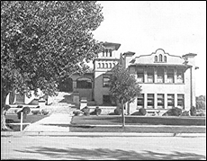
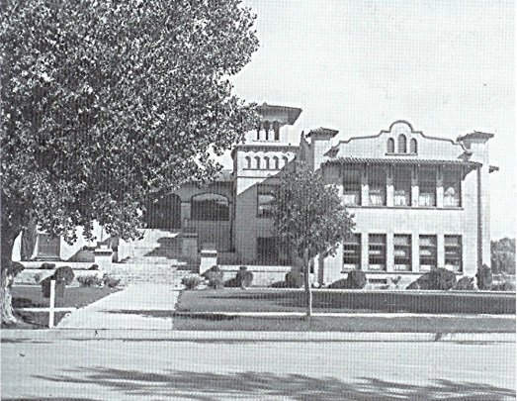
The cornerstone for the new Clark County School (later called the Las Vegas School) was laid as part of the Independence Day celebration on July 4, 1910. Delayed until wooden steps were replaced with concrete steps, the new two-story school opened on September 11, 1911. It was an 8-room building of concrete construction, designed in Mission architecture with a metal roof (fires were a constant concern). It was just south of Bridger, on the east side of the 4th Street. The main entrance was on 4th Street. The first two weeks were spent in review because books shipped from Reno were late arriving. There were 17 high school students. It accommodated all grades, with the high school students housed in the south wing until 1917.

In the fall of 1912 the Clark County High School was established in separate rooms of the grammar school and opened with 3 teachers. The first high school graduates were in 1913 (Winona Earl, Olive lake, Leland Ronnow and Herbert Squires). Commencement was held on May 30 in the second floor auditorium of the Clark County School. In 1914 and 1915 there were 6 graduates, and in 1916 there were 7 graduates.

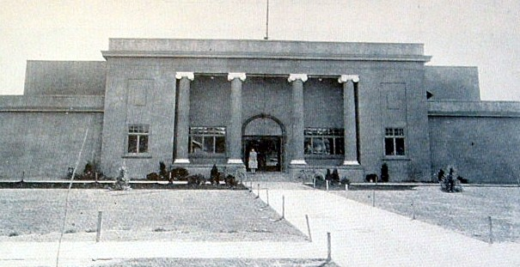
In 1916, plans were started for a separate high school near the northeast corner of 4th and Clark streets. The Clark County High School (later renamed Las Vegas High School) was completed in December, 1917 at a cost of $45,000. The building, with the entrance on 4th Street dignified with four concrete columns, included a gymnasium and auditorium. Students moved in on December 17, 1917. There was no school during October & November, 1918 due to a flu epidemic.

In the 1920-1921 school-year there was a faculty of 6, there were 12 graduates, scarlet and black were chosen as the school colors, and the first yearbook, called “Pah-Rah-Wah-Na” (the Paiute Indian phrase for “Rainbow”) was published. In 1922 the Manual Arts Building was built, and there were 6 graduates. In 1923 there were 10 graduates. In 1927, Maude Frazier became Las Vegas Superintendent of Schools and Principal of Las Vegas High School, the first girls’ volley ball team was formed, and the school was enlarged to almost twice its original size, with a new gym, additional classrooms and a new auditorium on 4th Street. Landscaping with shrubs and trees was added for the first time. In the fall, the first football team was formed under the guidance of coach Frank Butcher. The first football game ever played in Las Vegas was on Thanksgiving Day, November 24, 1927. LVHS beat Panaca 13-12.
In 1928, with the start of construction of Boulder Dam, the name of the yearbook was changed to “Boulder Echo” and a $5 award was given to the student that named it. There were 24 graduates. Plans were started for a new high school, designed for a student body capacity of 500, at 7th and Bridger. Many resisted, saying it would be “too far out of town” and would never be filled! There were 29 graduates in 1929, and 32 in 1930 - the largest class in the history of Las Vegas.
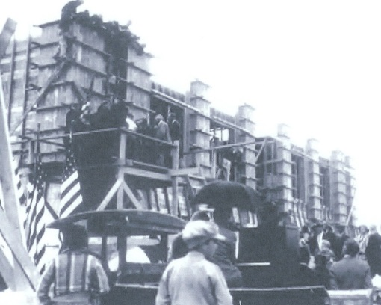
The new Las Vegas High School at 7th & Bridger, built at a cost of $350,000 in the Art Deco style, opened in the fall of 1930 and was dedicated on November 2. The original high school on 4th Street became part of the grammar school. That year the Honor Club was formed, the Desert Breeze newspaper was started, and Frank Butcher, Head of Athletics, died in a gasoline fire at the age of 26. In 1931, Butcher Field was named in his honor and the Boulder Echo was dedicated to him. In 1932, 15 issues of the Desert Breeze were published, and there were 75 graduates.
Laying of the cornerstone 04/11/30

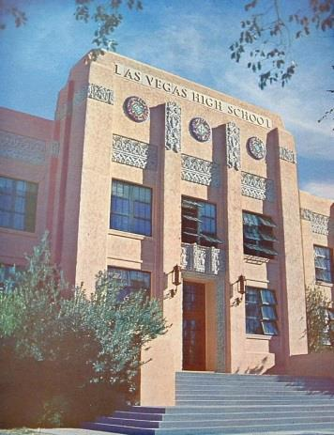
The Great Depression swept across the country and the unemployed converged on Las Vegas, hoping for jobs on the Boulder Dam project. In 1933, Boulder City became a reality and 165 high school students were bused to Las Vegas. LVHS enrollment jumped to 473 students and the “Wildcat” mascot was born. There were 100 graduates in 1934, and the Desert Breeze was expanded to two pages.

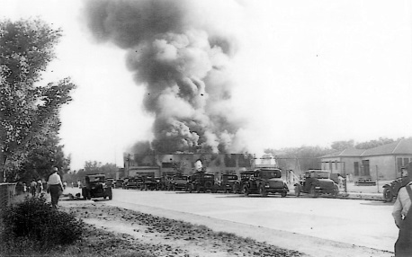
On May 24, 1934, the original Las Vegas High School, which had become part of the Las Vegas Grammar School, burned down. Wooden buildings with slanted tent-type canvas roofs and no windows, built on “skids” so they could be pulled into place, were placed just north of the burned-out school and used for the 6^{th,} 7th & 8th grades in 1934 and 1935 until the new 5th Street School was opened in 1936.

In 1935 there were 775 students enrolled in Las Vegas High (in the school built for 500), and in 1936 there were 69 graduates. In 1937, there were 91 graduates and Bill Nellis graduated. He was shot down over Luxembourg 4 years later and was memorialized by the naming of Nellis Air Force Base.

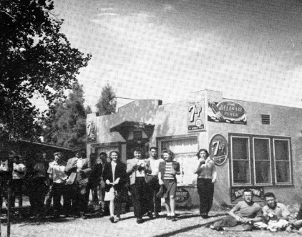
In 1941 Dougan’s Café (on the northwest corner of 7th and Bridger, later known as the “Kick-Off”) opened and became a favorite gathering place for students.

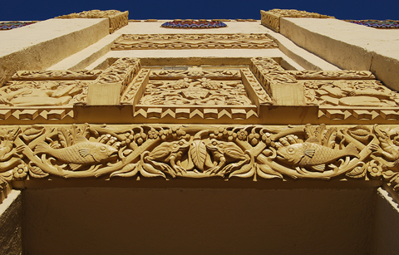
In 1943 yearbook photos were taken in groups to conserve paper during the war years, and 1944 saw the first decline in school enrollment due to the draft and enlistments. There were 107 graduates in 1945. In 1946, Maude Frazier retired after 19 years of service, the Annex Building and band room were added, George Early Harris became Principal, Walter V. Long became Vice Principal, and the Wildcat Lair was established at 4th and Stewart. In 1947 construction was started on Frazier Hall, the School Administration Building was added, Evelyn Stuckey formed the Pep Cat Drill Team and the marching band was organized. In 1949 Frazier Hall was completed, bleachers were added to Butcher Field, the Boulder Echo was renamed “Wildcat Echo” (because Boulder Dam was renamed Hoover Dam that same year). The Rhythmettes were formed, and over 1000 students were enrolled.

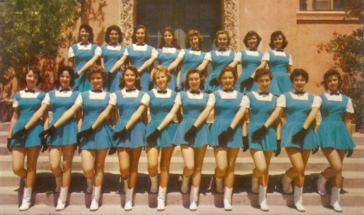
The first performance of the Rhythmettes was held in 1950. The senior boys formed the “Figuerettes”, and the first Rhythmette Revue was presented in 1951. In 1952, the Rhythmettes performed at the Hollywood Bowl, 200 girls tried out for 6 Rhythmette openings, bond issues were launched for a new auditorium and additional vocational shop space, and there were 228 graduates. In 1954, Butcher Field was enlarged, the new auditorium opened on the corner of 9th & Clark, there were 1820 students enrolled (in a school then built for 1500) and there were 283 graduates. In 1955 the Rhythmettes traveled to New York City and appeared on the Ed Sullivan TV show, there were over 1900 students enrolled, and there were 387 graduates. In 1956 the University of Nevada, Southern Division, shared space at LVHS, and there were 403 graduates, the largest graduating class in LVHS history and the last graduating class in Las Vegas where all seniors were in only one high school. Rancho High School opened in 1953, and Gorman High School opened in 1954; however, neither had Seniors until 1957. The Sir Herkimer Bone tradition for the annual football game with rival Rancho High started in 1957. In 1958 the Wildcat Lair closed.

In 1960 the Rhythmettes and LVHS Band appeared in the half-time production at a Ram’s game in the Los Angeles Coliseum. That year also saw the last Freshman class at LVHS (the class of 1963) when Junior High Schools came into existence. By 1961, everything at LVHS was getting bigger – including the Wildcat Echo and the Desert Breeze. Post Hall, named after Dennis James Post, a student that died of cancer in 1959, was opened. The Student Senate increased to 55 members and they continued the tradition of providing Thanksgiving baskets for needy families. In 1964, the Rhythmettes went to the Big Apple to represent Nevada at the New York World’s Fair. In 1966, Principal Walter V. Long retired after 28 years at LVHS, along with long-time teachers Joseph Thiriot, Eldon Larson, Gwendolyn Woolley and Warren Portenier. The Rhythmettes were disbanded in 1967 due to Evelyn Stuckey’s health. In 1968 the student body adopted a foster child, hoping the program would become a tradition. The same year Soccer was introduced for the first time and many grads were bound to Vietnam. In 1969 the band took honors at the California Music Festival and the Student Body sponsored a Vietnamese orphan.

In 1970 the Desert Breeze acquired a new headline machine and for the first time, subscriptions were sold (for $1.50). Evelyn Stuckey’s Flag Twirlers began in 1971, the new Student Union building opened, and the football team was the smallest and lightest, but beat Western for the first time! In 1972 more and more boys had long hair. In 1973 long, straight hair became vogue for the girls along with long floor-sweeping “granny dress” skirts, and the Flag Twirlers became the new Rhythmettes, once again led by Evelyn Stuckey. In 1976, LVHS was budgeted for 2500 students, Freshman were back for the first time since 1960, and a new group called Spectrum appeared on the campus. Sir Herk’s bone was returned to LVHS in 1977 after 4 years. Coach and Assistant Principal Harry Paille retired in 1979 after 30 years at LVHS, and the girls’ basketball team won the first State Championship in LVHS history. By the 1979-1980 school year, LVHS was the smallest public high school in Las Vegas, with only 1200 students enrolled. Population had moved to suburban areas and downtown was rapidly becoming mostly commercial.

Rhythmette founder Evelyn Stuckey died in April of 1980. In 1981, the Wildcats kept Sir Herk’s bone for the 5th straight year. In 1982 the Gymnastics Team was formed and performed at football and basketball halftimes. In 1984, the first Golden Graduation ceremony was held for the class of 1934. In 1986, the main building and gymnasium were placed on the National Register of Historic Places, and in 1987, Governor Richard Bryan (LVHS Class of 1955) signed a bill preserving LVHS as an historic landmark. In 1988 the auditorium was renovated, and the Men’s Bowling Team was ranked #1 in the nation. In 1991, the surrounding neighborhood, bordered by Bridger to Gass and 6th to 9th Streets, was also placed on the National Register of Historic Places. In 1992, the LVHS marching band performed at an UNLV rally for Presidential candidate Bill Clinton in October. Many students were already being bused in from the East, so they were rezoned to a new school, designated as Winchester High School, being built at East Sahara and Hollywood, near Sunrise Mountain. It was renamed “Las Vegas High School”, carrying on their image of excellence, pride and commitment, and embracing the historic legacy that is Las Vegas High School. Our “old” Las Vegas High School became the “Las Vegas Academy of International Studies, Performing & Visual Arts” in the fall of 1993. The LVHS class of 1993 was the last class to graduate from the 7th Street campus.

A NEW ERA BEGINS . . . .

In the fall of 1993, the new Las Vegas High School opened at 6500 E. Sahara. The class of 1994 was the first graduating class at the new campus, with 307 graduates.

The new campus on East Sahara is close to 10 miles from the 7th Street campus, compared to the previous jump of a few blocks. The new location at the eastern edge of Sahara Avenue mirrored the extreme growth of the Las Vegas Valley. The previous site is in good hands as it continues to serve high school students as a public, magnet high school dedicated to the performing and visual arts.
Symbols of tradition, including the Wildcat mascot, Sir Herkimer’s Bone, and the school colors of red and black have now guided a new generation forward. Athletic achievements and records that were destined to never be matched have now been expanded upon.

Written in 2013 by Patty Haack, Class of 1956, with help from LVHSAA Historian Joe Thomson. Sources: Las Vegas Age Newspapers 1910-1917, Las Vegas High School - Its People - Its Impact, published in 1992, a compilation of articles in the Las Vegas Sun Magazine from April-November, 1980, Chapter Seven of “Young Las Vegas, 1905-1931” published in the Las Vegas Review Journal on April 10, 2005, LVHS yearbooks, “Education in the Neon Shadow” by the Clark County School District and interviews with numerous LVHS alumni.

History of Las Vegas high School (Alumni Association) 1/19/2016 6:19 PM

