In celebration of our 65th reunion, the Class of 1959 will meet on the steps of the “old” LVHS, 315 S 7th Street on Friday, October 18 at 11 a. m. for pictures and then we will move to the library to share anecdotes and memories from our time at LVHS. You are welcome to bring pictures and other items you would like to share.

On Saturday, October 19th, we will all meet at the Orleans, 4500 W Tropicana, for the All-Class Reunion. Be sure to register early so you can sit at the Class of 1959 tables. You can register at LVHSAA.com. The cost of the All-Class Reunion is $65.00 if you register early.

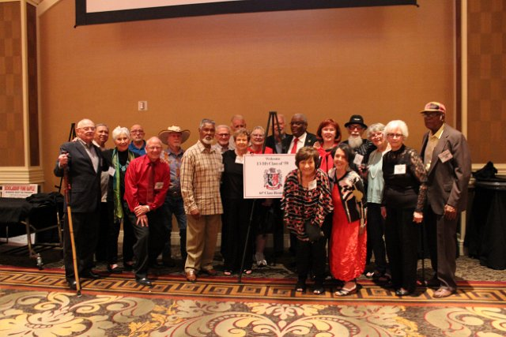

Our 60th Reunion

If you have questions, please contact:

Doug Wells, [deloycycle@gmail.com](mailto:deloycycle@gmail.com) 435-862-8866

Bobbie (Reed) Poole, [bpoole8118@gmail.com](mailto:bpoole8118@gmail.com), 702-813-8404

Sheila (Small) White, shelawyte@yahoo.com, 702-510-8318

LVHSAA email [lvhsaamain02@gmail.com](mailto:lvhsaamain02@gmail.com)

Please make sure LVHSAA has your correct mailing address.